**PROBLEM STATEMENT**

Swimming is one of the best exercises that helps people to reduce stress in this urban lifestyle. Swimming pools are found larger in number in hotels, and weekend tourist spots and barely people have them in their house backyard. Beginners, especially, often feel it difficult to breathe underwater which causes breathing trouble which in turn causes a drowning accident. Worldwide, drowning produces a higher rate of mortality without causing injury to children. Children under six of their age are found to be suffering the highest drowning mortality rates worldwide. Such kinds of deaths account for the third cause of unplanned death globally, with about 1.2 million cases yearly. To overcome this conflict, a meticulous system is to be implemented along the swimming pools to save human life.

By studying body movement patterns and connecting cameras to artificial intelligence (AI) systems we can devise an underwater pool safety system that reduces the risk of drowning. Usually, such systems can be developed by installing more than 16 cameras underwater and ceiling and analyzing the video feeds to detect any anomalies. but AS a POC we make use of one camera that streams the video underwater and analyses the position of swimmers to assess the probability of drowning, if it is higher then an alert will be generated to attract lifeguards' attention.

**TECHNICAL ARCHITECTURE**

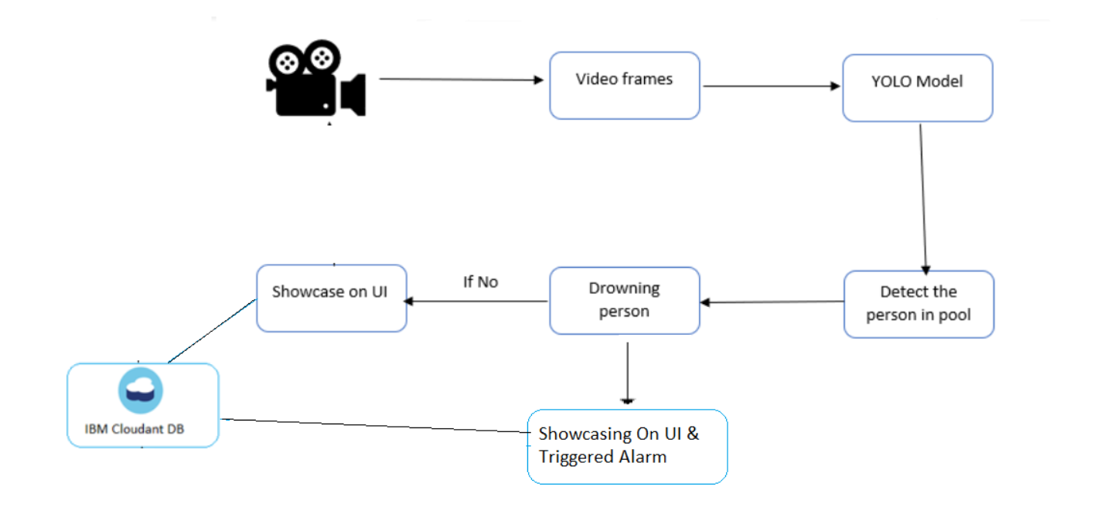

**LITERATURE SURVEY**

[1] Lei Fei, Wang Xueli, Chen Dongsheng, proposed a background subtraction method for drowning detection and swimmer identification using visual surveillance in their research paper. This method fails to reflect real background accurately thus restricting model accurate shape detection of moving objects. It also fails to reflect sudden background changes.

[2] Ajil Roy, Dr. K. Srinivasan, proposed drowning detection using RFID-based swimming goggles, however, this model also fails to overcome the limitation of accuracy since the water sensor is not placed very close to the mouth and nose. But this model successfully overcomes limitations of video surveillance-based drowning detection systems like the need for high power computing devices.

[3] Xu et al. has carried out a study to underwater classification of images using deep convolutional neural networks to improve the classification ability using augmentation methods such as aspect ratio augmentation and color augmentation.

[4] M. A. Hayat proposes a technique to detect a drowning person in the swimming pool using video image frames. A-frame by frame difference VIBE algorithm is used to detect drowning persons is demonstrated used to determine the swimmer's position.

[5] Jose, A. and Udupa, G. 2021. Gantry robot system for preventing drowning accidents in swimming pools

[6] Laxman, P. and Jain, A. 2019. A review paper on design and performance evaluation of drowning death prevention system with various technologies